**Creating an Owner Dashboard**

***Owner Report- Basic***

Purpose: To inform our owners about their unit performance; it focuses on providing fundamental insights without diving into more complex or granular details.

Tip: For this dashboard we are going to add three different sections

1. **Let’s Begin…**

* On the main Menu, Click “Dashboard”



* Go to My Dashboards and click on the “Create New” button

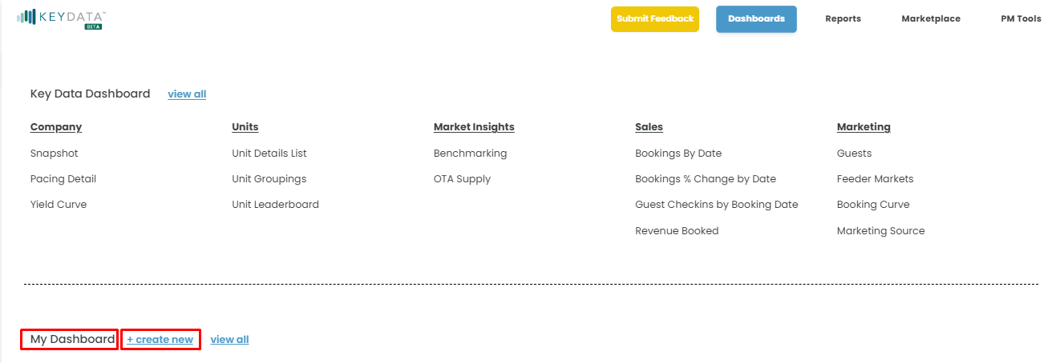

* Name your Dashboard, your first section and select your Anchor Date (Hint: for the 1st and 2nd section will be using the Arrival Anchor Date)

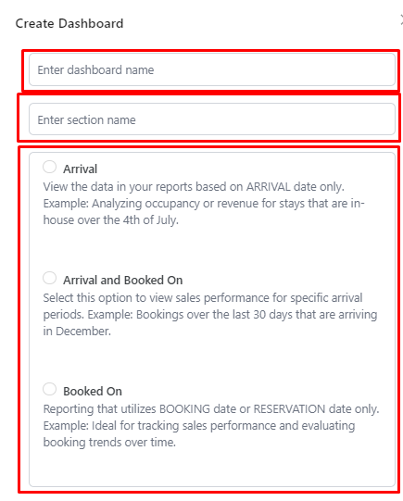

Anchor Date: Booked On for 3rd Section

Anchor Date: Arrival for 1st and 2nd Sections

Dashboard Name: Owner Report - Basic

Section Name: Unit Performance

1. **After creating the First Section title “Unit Performance”, a report catalog will appear.** *(Remember: The first section is a straightforward snapshot of how a unit is performing over time)*

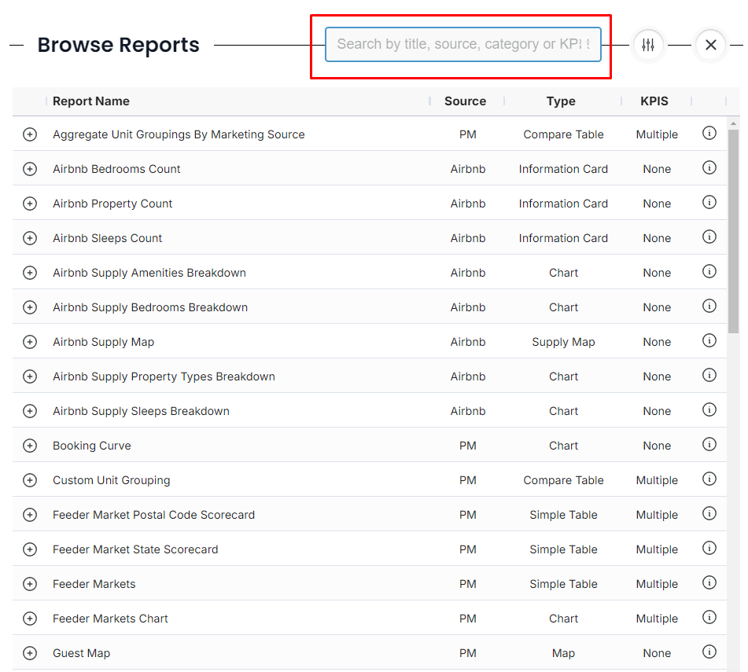

1. **From this catalog, browse and add the following reports to add:**

* PM Scorecards

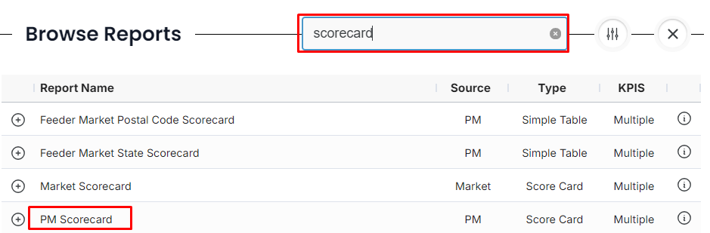

* Pacing Detail

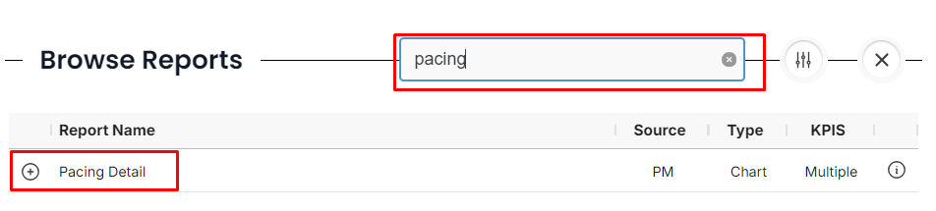

1. **Once you've added your preferred reports to this section, here are a few options you can explore, depending on the data you'd like to showcase:**

* 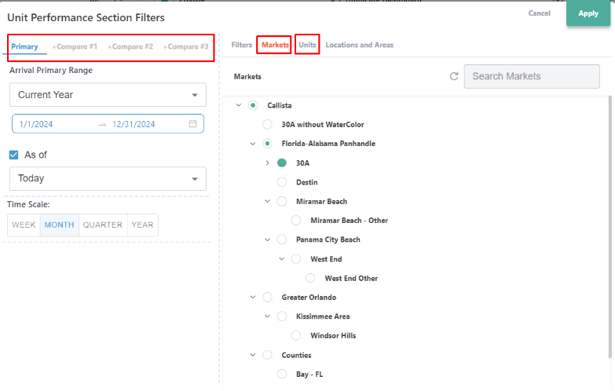Adjust your filters by clicking on the date filters:

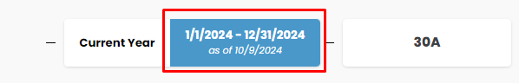

* When your filters expand you can do the following:
  + Select your primary date and comparison dates
  + Choose the market the unit belongs to
  + Select your preferred unit
  + Select preferred KPI at report level

(Suggestions: UNIT Revenue, Adj. RevPAR, APO,

ADR, Guest, Owner & Hold Nights

* + Rename, Duplicate and Delete Reports

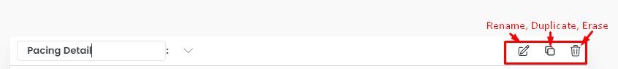

1. **Next, let’s create your second section, titled "Me vs. Market."** *(Remember: The second section is a market - high-level comparison involves benchmarking the unit's performance against the broader market)*

* We have two options
  + Duplicate your section to retain the same filters as the first section:



* + - After Duplicating your section, delete all reports
    - Rename the section

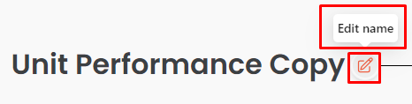

* + - Add Reports



* + - Add the following reports
      * Market + PM Benchmarking
    - Select preferred KPI at report level (Suggestions Adj. RevPAR, APO & ADR)
  + Create a new section



* + - Follow Step 2,3 & 4

1. **Finally, let’s create your third section, titled "** **Reservations Activity."** *(Remember: The third section tracks how well bookings are progressing, focusing on volume or timing trends)*
   * Create a new section - We want to create a new section because we will select a different anchor date
     + Name section and select your Anchor Date (Hint: Use Booked On Anchor Date for third section)
     + Add the following reports
       - Booking by Date,
       - Revenue Booked
       - Booking % Change
     + Adjust Filters
2. **Last Few Tips**

* Made a mistake? Clear your filters

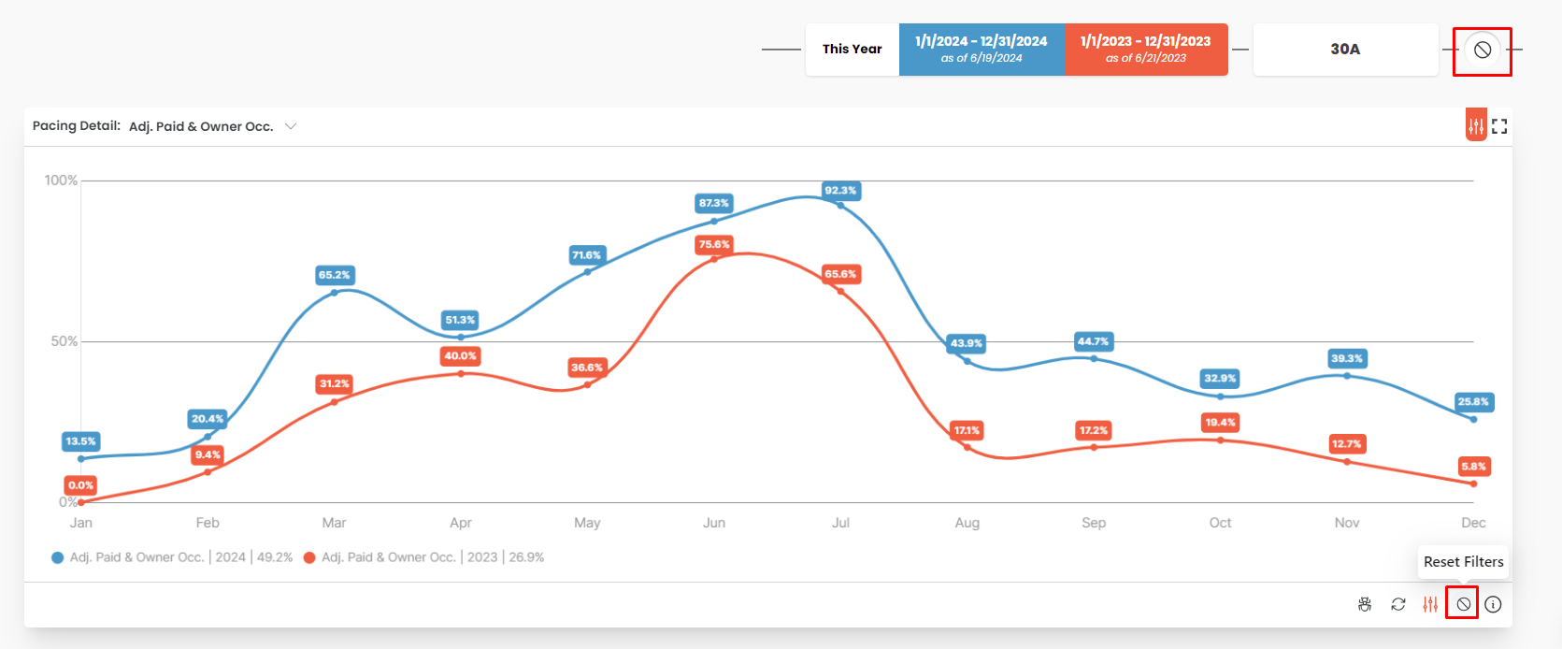

* Collapse and re-order sections within your dashboard



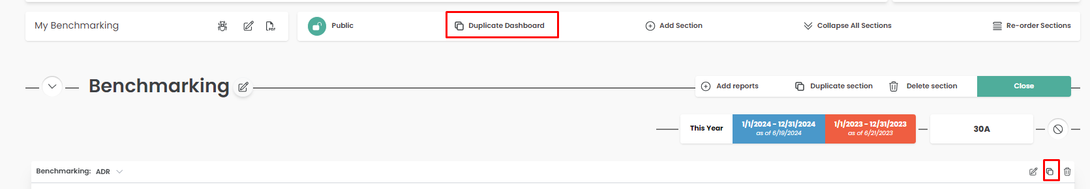

* Resize or move reports
* To move your report, Click and Drag
* To resize it, click on the bottom right corner of your report

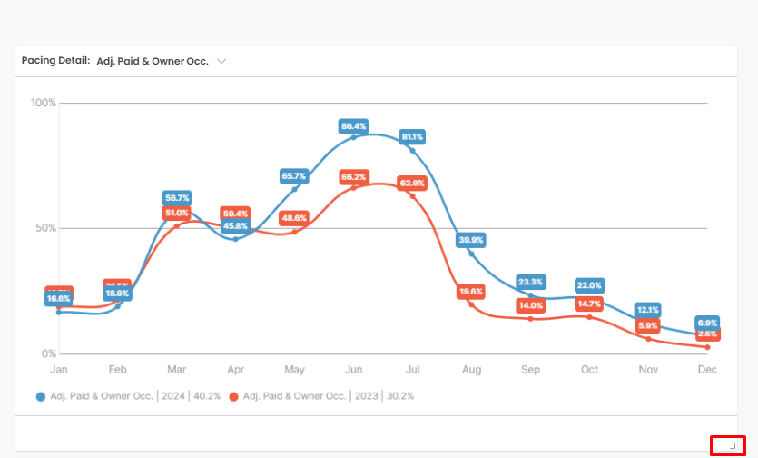

* Want a better view of the report? Detail View it

